BITTERROOT HOMESCHOOL ATHLETIC ASSOCIATION
Player Registration Packet

The Bitterroot Homeschool Athletic Association (BHAA) operates as a member of the Montana Christian Athletic Association (MCAA). All matters must be in accordance with MCAA guidelines, with competition rules as outlined by the Montana High School Association (MHSA) – off-season rules of the MHSA do not apply to MCAA teams (soccer MHSA Rules shall be used inside the framework of an eight-man game and non-varsity teams may be co-ed).

Please feel free to reach out to your BHAA representative with questions or for resolution of matters pertaining to your player’s sport.

Volleyball Rep. | OPEN
Boys’ Basketball Rep. | Amy Lewis | (406) 880-3115 | amylemongrass6@gmail.com
Girls Basketball Rep. | OPEN
Soccer Rep. | Jenn Sutton | (502) 424-8649 | jennpsutton@gmail.com
Ultimate Frisbee Rep. | Sam Euker | (406) 239-8162 | samueleuker@gmail.com
Athletic Director | OPEN
President | Sarah Harrington | (406) 370-6334 | tucksarah1999@gmail.com
Treasurer | Alicia Harrington | (406) 381-7329 | adeh1013@yahoo.com
Secretary | OPEN

Included (to be signed/initialed where indicated and returned to Team Representative)
- BHAA Player Registration Form - page 2 **parent sign**
- Acknowledgements - Page 3 **parent and student initial and sign**
- Concussion Statement page 4 **parent and student initial and sign**
Attachments
- Statement of Faith - page 5
- Commitment to Your Team - Page 5
- Player Agreement - page 5
- Expectations (BHAA Coach, Player & Parent Expectations) - page 6
- Liability Waiver - page 7
- Eligibility (MCAA Eligibility Guidelines & Code of Conduct) - page 8
- Fundraising Guidelines - page 9
- Current Season Anticipated Expenses
- Current Season Game Schedule
- MHSA Concussion Fact Sheets
- MHSA Confidential Athletic Pre-Participation Physical Examination Form* **return to rep
*Sports Physicals available at your medical provider of choice OR Marcus Daly Rehabilitation Center for $25 per student – please specify “Bitterroot Homeschool Athletic Association” as your school & all fees to MDMH will be DONATED back to our athletic program!

Bitterroot Homeschool Athletic Association
Player Registration

Name: ________________________________________________________ Grade: _____
Date of Birth: _____/______/________ Age: _________ Height: ________________
Address: ________________________________ City: ___________________ Zip: _______
Parent Names: _______________________________________________________________
Father’s Email: _______________________________ Father’s Phone: (_____) ___________
Mother’s Email: ______________________________ Mother’s Phone: (_____) ___________
Player’s Email: _______________________________ Player’s Phone: (_____) ___________

Medical Information:
Please describe any medical condition your coach needs to be aware of:
____________________________________________________________________________
____________________________________________________________________________
Insurance Carrier: _______________________________ Group ID #: _________________
Name of Policyholder: ____________________________ Individual ID #: ______________
Telephone Number for Insurance: (_____) ___________
Family Physician: ______________________________ Phone: (_____) ________________

In the event that this player should require emergency medical treatment while participating in the Bitterroot Homeschool Athletic program under the immediate supervision of its designees, I authorize professional medical services that may be deemed necessary.
Participation includes possible exposure to and illness from infectious diseases included but not limited to COVID-19. While particular rules and personal discipline may reduce this risk, the risk of serious illness and death does exist. I knowingly and freely assume all risks, both known and unknown, even if arising from the negligence of the releases or others, and assume full responsibility for my participation.
____________________________ ____________________________ _____________
Parent’s Name Signature Date

____________________________ ____________________________ _____________
Parent’s Name Signature Date

FINANCIAL:
Payment of $100(VBall, Soccer, BBall) or $75 (Ultimate) due at registration:
Received on _____________, check # __________
Refund Policy: full refund of the $100 ($75 Ultimate) registration fee will be given if an athlete drops out before the first 5 practices, after 10 practices a 50% refund will be given, and after the first game no refund will be given.
Raffle Tickets and Monies ($200) due by October/December 1. Received on ________________
Please initial and then sign the following acknowledgements:

Parent Player Initial:
Player Agreement (see attached Player Agreement and Expectations)
_____ ______I have read and agree to comply with the attached player expectations.

_____ _____ I understand the commitment to make every scheduled practice and
game, including participation in the state tournament.

_____ _____ If any unforeseen circumstance arises (illness or family emergency)
where I am unable to participate in an upcoming contest, I will let the coaches know immediately (1-2 week’s advance notice is preferable).

_____ _____ I will communicate with the coaches ALL dates in advance where I have a
current scheduling conflict and will reserve all future dates on the
calendar for full participation with the team.

Parent Agreement (see attached Parent Agreement)
_____ I have read, understood, agree with and will abide by the attached
Parents’ Agreement.

Liability Waiver
_____ _____ I have read the above Liability Waiver and assumption of risk agreement,
fully understood its terms, and understand that I have given up substantial
rights by signing it, and sign it freely and voluntarily without any
inducement.

Fundraising (see attached Fundraising Guidelines)
NOTE: This section does not apply to Ultimate Frisbee
_____ _____ I will commit to full participation in the team’s fundraiser, reaching
minimum individual goals.
_____ _____ I understand that if I do not reach minimum fundraising goals that I
will be responsible to make up the difference out of my own finances.

_________________________ _________________________ _____________
Parent’s Name Signature Date

_________________________ _________________________ _____________
Player’s Name Signature Date

Dates with a current scheduling conflict: ____________________________________

Volunteer Positions Needed

(circle areas where you can help)

Head Coach
Assistant Coach

Score Book

Equipment

Scoreboard (home games)

Line Judges (volleyball - 2)

Sponsor

Fundraising

Set-Up & Tear Down

Concessions

Team Communication Board Representative
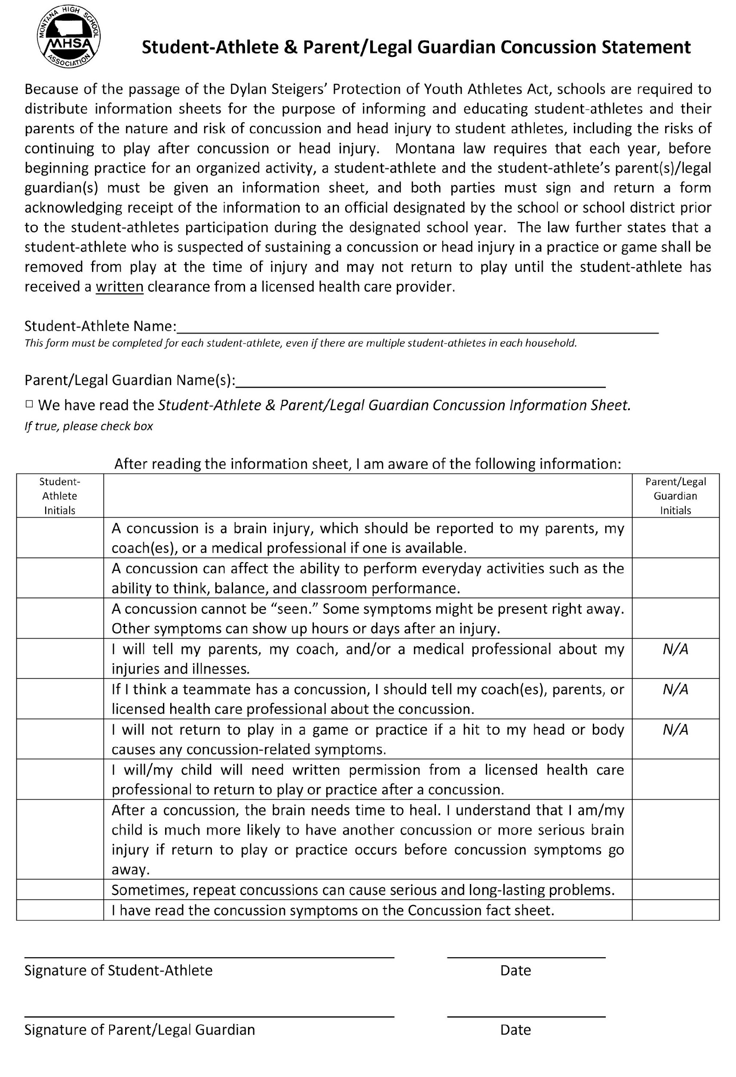

The BHAA Statement of Faith

The BHAA is a Christian organization, and as such will govern itself and operate its teams according to its Statement of Faith. We believe in and unqualifiedly affirm:
- The inspiration of the Bible, equally in all parts and without error in its origin.
- The one God, eternally existent Father, Son, and Holy Spirit, who created man by a direct immediate act.
- The pre-existence, incarnation, virgin birth, sinless life, miracles, substitutionary death, bodily resurrection, ascension to Heaven, and second coming of the Lord Jesus Christ.
- The fall of man, the need of regeneration by the operation of the Holy Spirit on the basis of grace through faith and the resurrection of all; to life or damnation.
- The spiritual relationship of all believers by the Lord Jesus Christ, living a life of righteous works, separated from the world, witnessing His saving grace through the ministry of the Holy Spirit.

Commitment to Your Team
Athletes are expected to commit themselves to the program and continued self- development. The realization that practice sessions are important is a premise that is vital to a successful sports program and player. Athletes and parents should be prepared for a weekly commitment for games and practices. It is vital that each member understands and accepts their role on the team, as the number of roster positions is relative to the student’s acceptance of their individual roles in pursuit of team goals. Athletes are expected to attend every practice and contest, unless excused by their coach. Timely communication between the coach, parent, and/or athlete is essential.
For all team members, meaningful contest participation will exist over the course of a season, providing the athlete meets program expectations. A specified amount of playing time, however, is never guaranteed. All registered players who pay fees are guaranteed full access to practices and coaching. As a competitive program, the amount of game time and varsity/junior varsity placement is at the sole discretion of the coach. All athletes must work to earn their play time. Athletes are expected to compete for a position, and earn their position in the starting line-up. The expectation is the same for the starting player as it is for the limited role player. Every athlete involved on the team has a role in preparing the team for a demanding competitive schedule.
Player Agreement
As a player I agree to abide by the expectations set forth in the MCAA Code of Conduct (see attached), as well as the disciplinary guidelines and team rules of this organization. I understand that my actions may have consequences, and failure to abide by BHAA and team rules may result in suspension or expulsion from the team. I understand that I will be held accountable by parents, coaches, and fellow athletes.

Bitterroot Homeschool Athletic Association
Coach, Player & Parent Expectations
“So whether you eat or drink or whatever you do, do it all for the glory of God.” (1 Corinthians 10:31)

BHAA expects its Coaches to:
- Be responsible for their own behavior and also the behavior of their team members, their parents, and fans.
- Lead by example in being respectful of other players, coaches, fans, and officials at all times.
- Provide a sports environment for their team that is free of drugs, tobacco, alcohol, and abusive language at all BHAA events.
- Place the emotional and physical well-being of their players ahead of a personal desire or external pressure to win.
- Never publicly demean a player, official, opposing coach, or parent.
- Ensure that their players are supervised by a coach or another designated adult and never allow their players to be left unattended or unsupervised at a game or practice.
- Never knowingly permit an injured player to play or return to the game.
- Take reasonable steps to see that all equipment used by their players is safe and conforms to standards.
- Take the initiative in resolving any known or suspected conflict relating to a player or family.
- Accept positive and negative feedback graciously as from the Lord.
- Communicate expectations – including these BHAA expectations – clearly to players and parents.

BHAA expects its Players to:
- Be courteous to opposing teams and treat all players, officials, and coaches with the utmost respect, whether or not they agree with a call
- Be modest in victory and gracious in defeat.
- Demonstrate good sportsmanship before, during, and after games. Stay composed and exercise self-control.
- Respect the privilege of using playing facilities by cleaning up benches, locker rooms, stands, and grounds after a practice or game.
- Refrain from use of alcohol, tobacco, and illegal drugs.
- Avoid profanity or demeaning speech on all occasions, on and off court, even in the “heat of competition.”
- Be an encourager.
- Understand that the TEAM comes before the personal feelings of an individual player.
- Be willing to serve in any role to build TEAM success.
- Show up for practice on time, with proper equipment, and ready to play.
- Make reasonable efforts in advance to be excused from any scheduled classes or activities that conflict with practices, games, or team functions.
- Communicate to the coach ahead of time when they will miss a practice or game.
- Dress in a manner that could not be considered offensive or morally suggestive at all BHAA events.
- Tell the coach of their concerns or problems instead of talking to others about them.
- Seek to resolve personal conflicts with teammates. Speak to them first and seek reconciliation.
- Maintain the dignity and privacy of my teammates at all times and on all platforms.

BHAA expects Parents to:
- Trust the coach to coach the team and support him/her in decisions, regardless of your agreement. This is a competitive, high-school level athletic program. This includes allowing the coach to determine the appropriate amount of game play time and refrain from “coaching from the sidelines.”
- Volunteer to help with team needs whenever possible.
- Let the officials and umpires call the game, maintain self control and remember that they too are only human and that rarely is the outcome of a game determined by a “bad call.”
- Demonstrate exemplary sportsmanship at games by using only positive cheers and never laughing at errors or jeering an opponent or their fans.
- Advocate a sports environment that is free of drugs, tobacco, alcohol, and abusive language, including profanity, and refrain from their use during any BHAA event.
- Assist his/her athlete to show up to practice and games on time, with proper equipment, and ready to play. Recognize that this is a travelling team and it is the parent’s responsibility to get their athlete to and from away games or make appropriate arrangements,
- Direct his/her athlete to communicate directly to the coach in advance of any anticipated missed practices or games.
- Direct his/her high-school athlete to speak directly to the coach privately (and not to others) about any issues concerning any aspect of their participation on a BHAA team.
- Encourage his/her athlete to abide by team rules, program guidelines and social media etiquette.
- Speak to the Athletic Director about any issue not adequately resolved with a coach.
- Be familiar with the MCAA rules of eligibility and to notify the coach of any reason their athlete might not qualify to play with BHAA.
- Obtain the proper medical release if a player has been removed from a game or practice with a suspected concussion.
- Accept financial responsibility for any willful or malicious damage resulting from my player’s or family’s actions.
- Fill out the post-season evaluations with truth and love.

Liability Waiver
In consideration of the acceptance of my player’s entry into the BHAA program, I hereby, for myself, heirs, executors, and personal representatives, waive and release any and all rights and claims for damages I may have against sponsors, organizers, and volunteers of said athletic organization or their representatives. I waive and release any and all damages or injuries incurred due to my player’s participation in said athletic organization. I understand that sports have certain inherent dangers and I accept and understand those risks.

Although the BHAA may carry medical or liability insurance, I understand that having medical insurance to cover my player while participating in the athletic program is my personal responsibility.

MCAA By-Laws – Article V: Abbreviated Rules to Be Used for MCAA Sports
5.A. ATHLETE ELIGIBILITY
5.A.1. Age and Graduation
5.A.1.a.No student is eligible to participate in the MCAA who has turned 19 on or before August 31st of that school year.
5.A.1.b.No student is eligible to participate in the MCAA who has received a GED.
5.A.1.c.No student is eligible to participate in the MCAA who has gone through a graduation ceremony.
5.A.2 Student athletes are allowed to participate in the MCAA at the High School Varsity level for four (4) years.
5.A.2.a.An extension of a fifth (5th) year of participation will be granted to those students who are in the eighth (8th) grade and participation at the High School Varsity Level. The Board of Directors must be informed in writing of such participation.
5.A.2.b.Seventh (7th) grade student athletes are allowed to participate in the MCAA at the High School level only when the total athlete participation is below the following numbers: Soccer—12; Volleyball—9; Basketball—10, without losing a year of eligibility. The Board must be informed in writing of such participation.
5.A.2.c.Seventh (7th) grade student athletes are allowed to participate in the MCAA at a Sub-Varsity High School level without losing a year of eligibility. The Board must be informed in writing of such participation.
5.A.3. Any student who is not in full-time attendance at an MCAA member school/ association, must have Board approval. A written request for a Board ruling must be made prior to participation.
5.B. MCAA ATHLETIC PARTICIPATION
5.B.1. Players must play for the respective team in their geographic area at which they must be in full-time attendance. No student may establish athletic eligibility concurrently at two schools. Dual enrollment is not recognized for the purpose of eligibility in MCAA activities.
5.B.2. Girls play girls’ sports and boys play boys’ sports.
5.B.3. A student enrolled in an MCAA member school in which no high school program is available to him/her may, upon Board approval, be granted eligibility to participate within the program of an alternate MCAA organization in the student's geographic area.
A student with no program available to him/her, who is not enrolled in a member school but who wishes to participate within the MCAA, must submit a formal written statement to the Board requesting the privilege to participate as an eligible athlete within a specific member organization.
A student enrolled in a school which is a member of a high school athletic association other than the MCAA will not be granted permission to participate in an MCAA program.
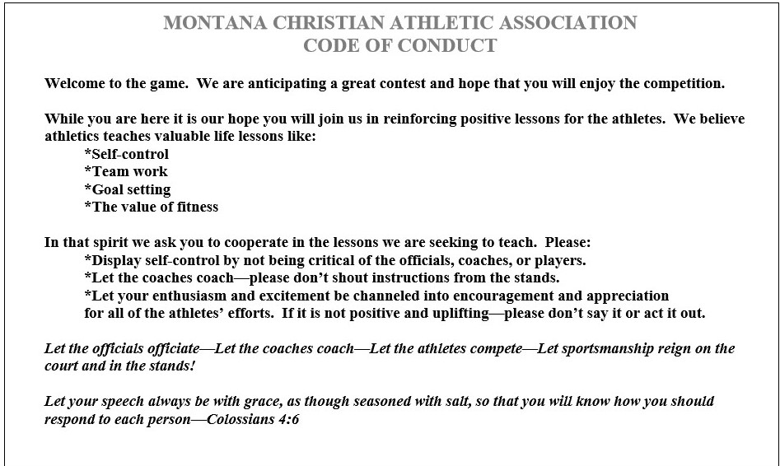

Bitterroot Homeschool Athletic Association
Fundraising Guidelines
NOTE: This section is not applicable to Ultimate Frisbee

PRIMARY FUNDRAISER (raffle tickets)
Participation in the primary fundraising activity is encouraged to promote individual growth, as well as to foster a team-building experience. Full participation in the team's primary fundraiser for the year is strongly encouraged. Fundraising plays a vital role in the development of the athlete. Not only does fundraising lay a foundation for the future growth and success of the program, but achievement outside of one’s comfort zone and communicating with the public serve to build a cohesive team spirit and personal confidence.

Alternate fundraising activities (car washes, etc.) must be submitted in writing and approved by the BHAA board prior to said activity, and are the sole responsibility of the individual choosing to organize such activity. Such additional activities MAY, with written board approval, replace the player’s participation in the primary fundraiser but will not replace their responsibility of minimum fundraising goals. If the individual’s minimum goal is not met (i.e. 10 raffle tickets), the player is responsible to make up the difference in funds. All fundraising funds (whether from the raffle tickets sales or alternate activity) are due at the same time. (i.e. October 1 for fall sports and December 1 for winter sports).

SPONSORSHIPS
Sponsorships are not a substitute for the primary fundraiser. Team budgets are set based upon anticipated fundraising activities. Requests for sponsorship fulfill additional needs of the team, as specified by the donor per the sponsorship form. Advertising by sponsors will appear in all sports’ programs.

CONCESSIONS
Concession sales are voluntary and based solely upon parent interest. The individual parent is responsible to purchase concession items, provide change to customers, track income and expenses, and to organize other parents to help (filling roles to manage the athletic contest takes precedence).

Parents interested in providing concessions should submit to the BHAA board a written proposal of concession items they will provide and a plan for managing sales & communication to home and competing teams, as well as for facility clean-up and garbage removal (clean-up includes kitchen and all areas where food is eaten). Concession sales are expressly for the benefit of the team/organization. The church does not approve any for-profit activity. All profits should be turned in to BHAA representative in a timely manner.

Concession sales requiring the use of a kitchen must contact Lone Rock Bible Church and complete a facility use form in advance. Athletic activities are specifically not permitted to use the kitchen unless approved in advance by the deacons. It is the responsibility of the concessionaire to confirm with the church whether the activity has been approved. Approval should not be assumed.

